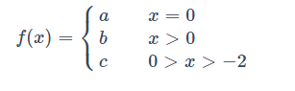

function z = myfun(x,a,b,c)

if x == 0
z = a;
elseif x > 0
z=b
elseif x<0 && x>-2
z=c;
end

